LRC SUB
The Learning Resources Center (LRC) at the Göttingen State and University Library (SUB) is a location equipped with PC working station and additional technology for researching, editing and printing media and documents. For doing so, the following features are available:
- modern Windows work stations
- high speed internet access
- access to Göttingen's university catalogue online (GUK) as well as the data bases of the Göttingen State and University Library (SUB)
- extensive software packages (Microsoft Office, Adobe Creative Suite, SPSS etc.)
- studIT helpdesk with six consulting hours every day
- A4 and A3 flat bed scanners, one slide scanner
- one video editing workplace
- a printing system providing five high performance b&w printers and one colour printer for printing in A4 and A3
- one plotter for printing posters in large size A0
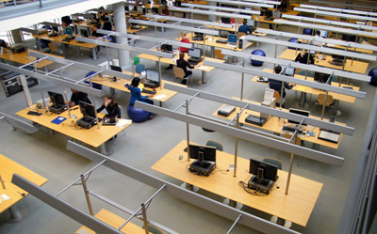
- lever shears
- notebook work stations with Wi-Fi access
- reference library for the software available

FAQ
Here are some frequently asked questions:

Who can use the LRC SUB?
All students, lecturers, scientists, employees of Göttingen University and other connected institutions as well as private users and guests of the Göttingen State and University Library are allowed to use the computer based work stations at the LRC SUB. As a matter of course, using the computers at the LRC (except for printing) is for free. Please note the terms of use of the LRCs!

How can I log in to the computers?
For logging in to the computers you need an account. Students at Göttingen University receive their account together with their student ID at the beginning of their studies. Owners of a GWDG account are also able to log in to the computers. With these accounts it is possible to use the Wi-Fi (GoeMobile/eduroam) at the SUB as well.

Where can I get help/ advice?
studIT is the IT service provider for students at Göttingen University. On working days our advisors from studIT are working six hours a day. You also can find advice on our SOS (studIT Online Support) homepage, which you can access via quick links on your desktop.

How can I print?
All Drucker available at the LRC SUB are connected automatically to the computers. You only have to choose the right printing queue (e.g. A4 b&w or colour). You can find the names of the printing queues on the little banners/ flyers at the work stations. After logging in to the computer you can see your current print contingent on the screen. You can top up your print contingent at the chip card issue point in the main lecture hall building by paying with your student ID. Print contingent of the GWDG accounts will be balanced by the respective institute.

Software available
All computers at the LRC SUB are Windows computers. On all PCs Microsoft Office as well as Acrobat Professional by Adobe are installed by default.
Further programmes (not on all computers available):
- Adobe Creative Suite, contains Photoshop, InDesign, Illustrator
- at some computers (video editing workplace) also Adobe Premiere is installed
- Abby Fine Reader
- Scan Software (Optibook)
- SPSS 20
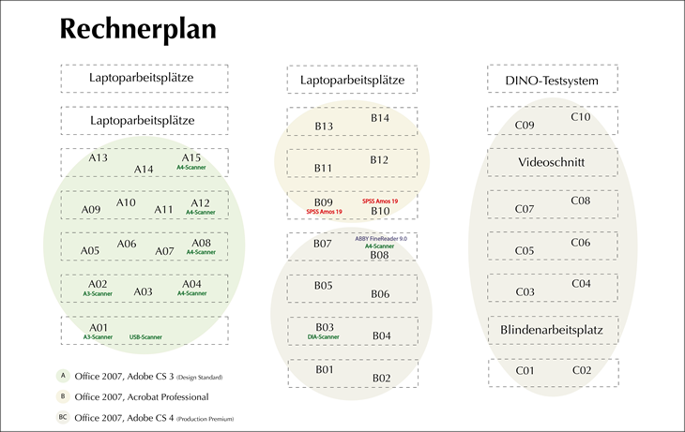
tag> lrc sub goettingen state and university library

