LRC KWZ
The Learning Resources Center (LRC) at the cultural studies divisional library (Bereichsbibliothek Kulturwissenschaften BBK) at the cultural studies center (Kulturwissenschaftliches Zentrum KWZ) is a location equipped with PC working station and additional technology for researching, editing and printing media and documents. For doing so, the following features are available:
- 24 modern Windows work stations
- high speed internet access
- access to Göttingen's university catalogue online (GUK) as well as the data bases of the Göttingen State and University Library (SUB)
- extensive software packages (Microsoft Office, Adobe Creative Suite etc.)
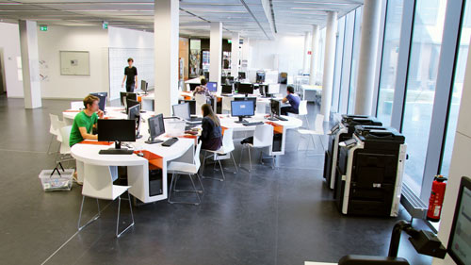
- two A4 flat bed scanners, one slide scanner
- two video editing workplaces
- A3/ A4 printers (direct and follow me printing)
- photocopiers
- notebook work stations

FAQ
Here are some frequently asked questions:

Who can use the LRC KWZ?
All students, lecturers, scientists, employees of Göttingen University and other connected institutions as well as private users and guests of the Göttingen State and University Library are allowed to use the computer based work stations at the LRC KWZ. As a matter of course, using the computers at the LRC (except for printing) is for free. Please note the terms of use of the LRCs!

How can I log in to the computers?
For logging in to the computers you need an account. Students at Göttingen University receive their account together with their student ID at the beginning of their studies. Owners of a GWDG account are also able to log in to the computers. With these accounts it is possible to use the Wi-Fi (GoeMobile/eduroam) at the KWZ as well.

How can I print?
All Drucker available at the LRC KWZ are connected automatically to the computers. You only have to choose the right printing queue (e.g. A4 b&w or colour). You can find the names of the printing queues on the little banners/ flyers at the work stations. After logging in to the computer you can see your current print contingent on the screen. You can top up your print contingent at the chip card issue point in the main lecture hall building by paying with your student ID. Print contingent of the GWDG accounts will be balanced by the respective institute.

Software available
All computers at the LRC KWZ are Windows computers. On all PCs Microsoft Office as well as Acrobat Professional by Adobe are installed by default.
Further programmes (not on all computers available):
- Adobe Creative Suite, contains Photoshop, InDesign, Illustrator
- on some computers (video editing work stations) Adobe Premiere is installed as well
- Scan Software (ScanWizard)

tag> lrcs lrc kwz cultural studies divisional library

