Access your student e-mail account via browser
You can check your e-mail anywhere and anytime via eCampus. If the eCampus portal is down (maintenance or technical problems), you can also access your mail directly via Outlook Web Access.
1. open browser
2. browse to the following URL: http://email.stud.uni-goettingen.de
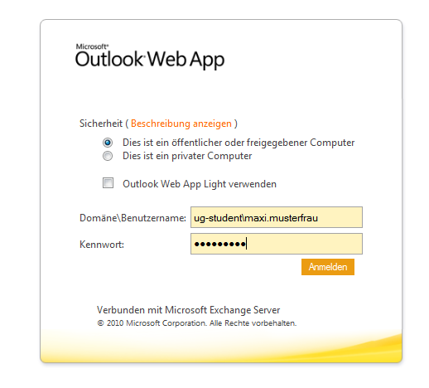
3. enter user id:
- ug-student\accountname (e.g. ug-student\m.musterfrau).
- password
4. edit emails in the web-based email client
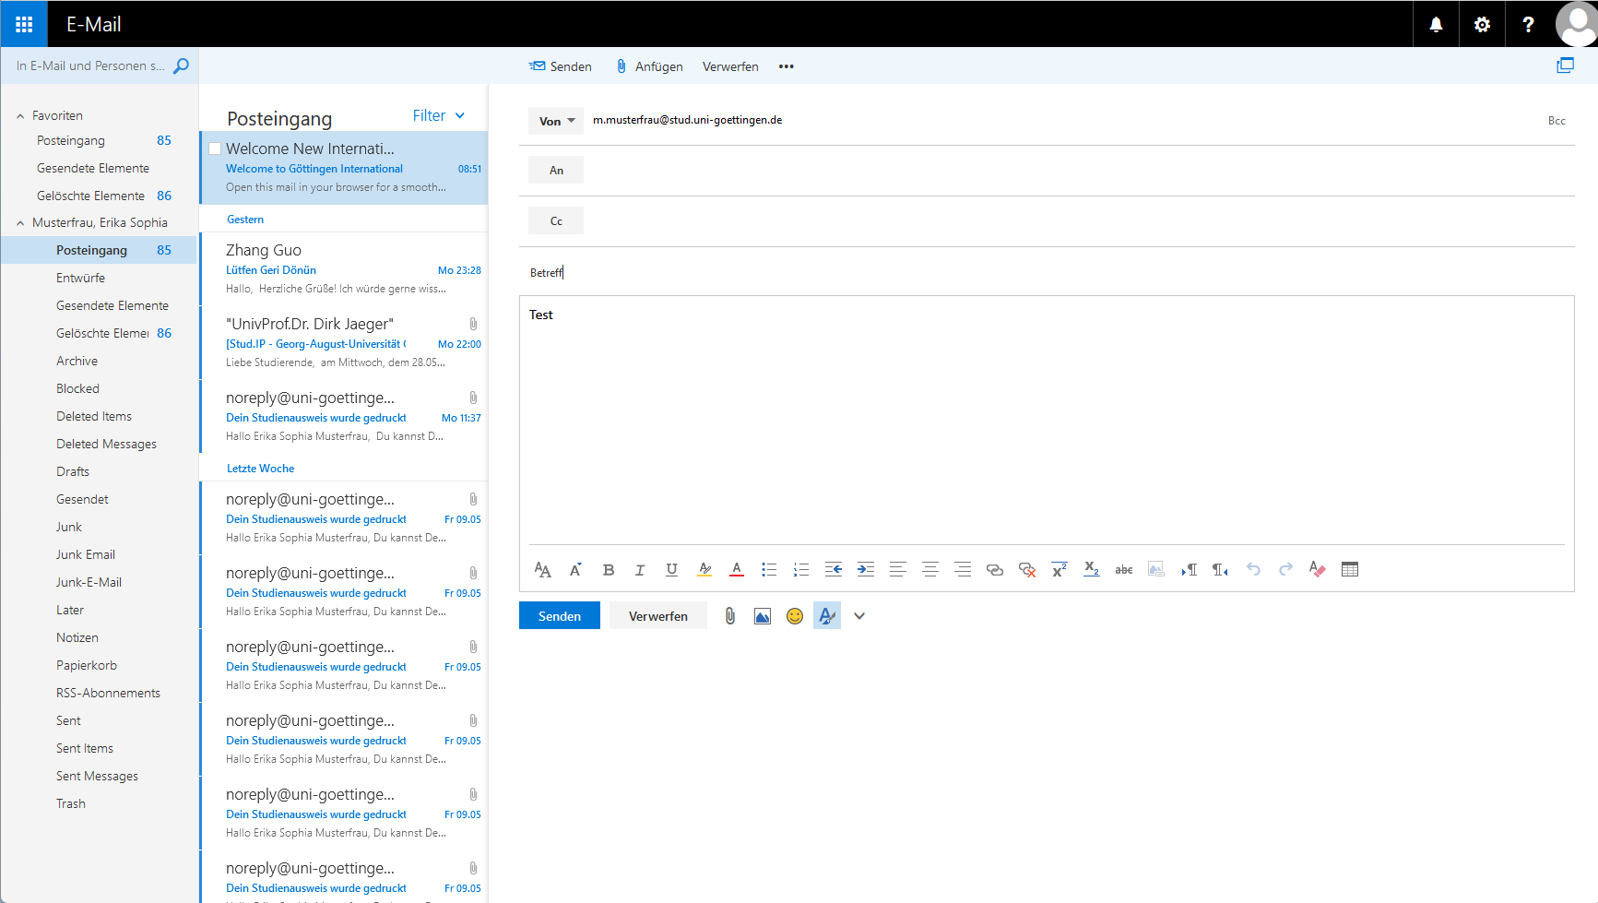
tag>mail mails address webmail student account webmail client mailer exchange server

