Connect to your home directory as a network drive
You can only access your home directory from a PC that is inside the universities network (for example eduroam). If you want to access your files from „outside“ you'll first need to establish a VPN connection. More on that can be found at VPN

Network Drive on Windows
- Open a new window in File Explorer (e.g. win + E)
- right-click on „Network“ and select „Map network drive…“
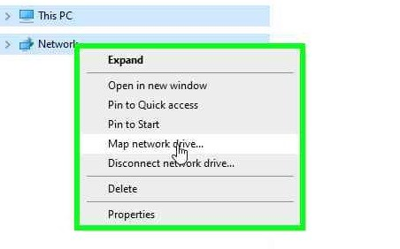
- in the new window choose an unoccupied drive letter and enter the following address (substituting „user.name“ with your actual student username):
\\ug-uyst-fs.student.uni-goettingen.de\home\users\user.name
- make sure to tick „Connect using different credentials“
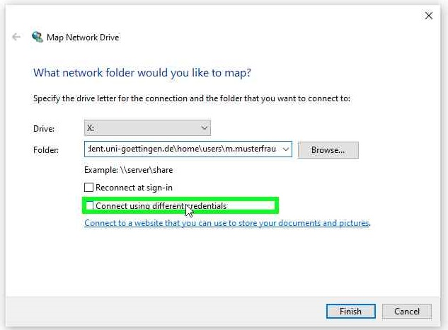
- After clicking „Finish“ enter „ug-student\user.name“ (again substituting „user.name“ with your actual student username) as the username and your student password in the new window
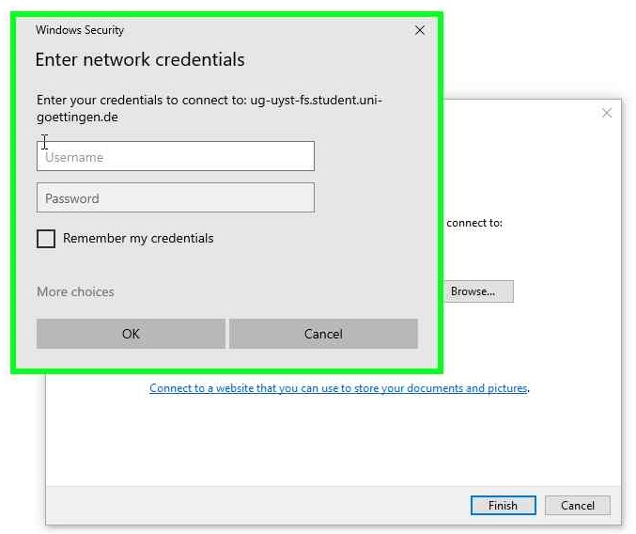
- A new window will open, showing your familiar home directory

